

UNIVERSITY OF TECHNOLOGY, JAMAICA Declaration of Authorship

FACULTY: Faculty of Engineering and Computing

School/Department: School of Computing and Information Technology

Course Code & Title: CMP2006 & Data Structures

Submitted To: Mr. Rorron Clarke

(Lecturer/Supervisor)

Submitted By: Gabriel Tickle Garcia

Student's name

2007394

ID Number

Freeport, Montego Bay, St.James, 1876 599 3666

Address, home, cell & work Tel. Numbers

Date of Submission: April 12, 2022

Title of Assignment: Data Structures Programming Project



Declaration: I certify that I am the author of this paper and that any assistance I received in its preparation is fully acknowledged and disclosed in the paper. I have also cited all sources from which I used visuals, data, ideas or words, either quoted directly or paraphrased, I also certify that this paper was prepared by me specifically for this course. I also understand that a grade will not be assigned without the submission of this agreement,

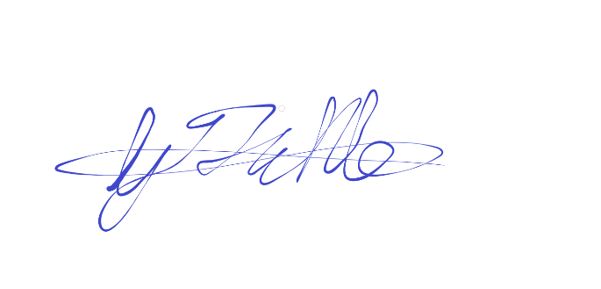Student's Signature:





Lecturer's/Supervisor's Grade for Assignment:

Lecturer's/Supervisor's Comments:

Note: For group assignments each student is required to complete a separate Declaration of Authorship.

Division of Student Services & Registry

Ref: Regulation 5: Conditions and Procedures September 2004

Governing Student Academic Misconduct